

# Sailing Instructions

Double Ree

# Youth Double-Handed Regatta

**15th – 17th July**

**Mirror National Championship**

**16th – 17th July**

**Feva Inland Championship**

**420 Connaught Championship**

**29er Western Championship**

Organising Authority: Lough Ree Yacht Club (LRYC) Ballyglass, Athlone, Ireland

## RULES

* 1. The regatta will be governed by the rules as defined by *The Racing Rules of Sailing* (RRS), the Notice of Race (NOR) and these Sailing Instructions (SIs)
  2. All relevant class rules will apply.

## REGISTRATION & BRIEFING

## 

## MIRRORS

Registration 9:00 to 10:30 on Friday, 15th July

Briefing 10:30, 15th July

,

**2,2 ALL OTHER CLASSES**

Registration 19:00 to 20:00 on Friday 15th July

and 9:00 to 10:30 Saturday 16th July

Briefing 10:30, 16th July

## NOTICES TO COMPETITORS AND SIGNALS MADE ASHORE

* 1. **Notices to competitors will be posted on the Official Notice Board situated in a front window of the clubhouse**
  2. **Any change to the schedule of races will be posted by 21:00 hours on the day before it will take effect.**
  3. **Any changes to the SIs will be posted on the official Regatta Notice Board at least 90 mins. before the first start of the day and indicated by displaying flag L ashore.**
  4. **Signals made ashore will be displayed from the flagpole outside the club.**

**When flag AP is displayed ashore, ‘1 minute’ is replaced with**

**‘not less than 30 minutes’ in the race signal AP.**

## 

## SCHEDULE OF RACES

|  |  |  |
| --- | --- | --- |
| **Date** | **Race** | **Warning signal** |
| Friday July15th | 3 races Mirrors only | **11:55** |
| Saturday July 16th | 3 Races Mirror, 420, Feva,  5 races 29er | **11:55** |
| Sunday July 17th | 3 Races Mirror, 420, Feva,  5 races 29er | **09:55** |

**Races scheduled for each day will be raced back-to-back.**

Nine Races are scheduled for Mirrors.

Six races are scheduled for 420s and Fevas

Ten races are scheduled for 29ers

**5 CLASS FLAGS**

29ers International code **Flag J**

420s **Class Association Flag**

Mirrors International code **Flag 6**

Fevas International code **Flag F**

## 6 RACING AREA AND COURSE

Racing will take place on Lough Ree, north of the Yellow islands. See **Addendum A**

See **Addendum B** for courses

In adverse weather conditions, the Race Officer may at his discretion for safety reasons, change the race area and / or courses, sail selected classes or abandon racing for silver and / or bronze fleets.

## 7 RACING MARKS

FRIDAY

Pin end of the start line **White and red pole in a rib OR a White Buoy**

Mark 1 **Orange/Red pyramidical mark**

Marks 2 & 3 **Tall yellow cylindrical marks**

Pin end of finishing line **Black Buoy**

SATURDAY & SUNDAY

Pin end of the start line **White and red pole in a rib OR a White Buoy**

Marks 1A and 2 **Tall yellow cylindrical marks**

Mark 1B **Orange/Red pyramidical mark**

Marks 3S, 3P, 4S, 4P **Round yellow buoys**

Pin end of finishing line **Black Buoy**

## 8 THE START

The starting line will be between the Race Committee Flagship’s

**Mizzen mast** and a **White and Red pole in a rib OR a White Buoy.** The race committee boat will fly an **orange** flag to indicate racing will commence shortly.

* 1. The fleets will start in the following sequence:
     1. Mirrors
     2. Fevas
     3. 420
     4. 29ers
  2. The sequence may be changed at the discretion of the Race Officer.
  3. If any part of a boat’s hull, crew or equipment is on the course side of the starting line during the two minutes before her starting signal and she is identified, the race committee will attempt to indicate to the boats their position by raising Flag V. Failure to indicate will not be grounds for a request for redress. This changes rule 62.1(a).

## 9 CHANGE OF THE NEXT LEG OF THE COURSE

## 

## To change the next leg of the course, the race committee will move the original mark

## (or the finishing line) to a new position.

## A sound signal and code flag C may be used to draw attention to the change.

## This changes *RRS* 33

## 10 THE FINISH

The finishing line will be

between a mast flying a **Blue Flag** on a committee boat and a **Black Mark**.

**11 PENALTY SYSTEM**

For the **29er class only**, the following will apply:

The “Two-Turns Penalty” is altered to “One-Turn Penalty”. This changes *RRS* 44.1

## 12 TIME LIMIT

A boat that does not start within 4 minutes after her starting signal will be scored Did Not Start (DNS) without a hearing

|  |  |  |  |
| --- | --- | --- | --- |
| Fleet | Time Limit for First Boat | Finish Window | Target Time |
| 29ers | 60mins | 15mins | 30mins |
| All other Fleets | 75mins | 15mins | 40mins |

If no boat has passed Mark 1 within 15 minutes the race will be abandoned. Failure to meet the target time will not be grounds for redress. This changes RRS 62.1(a).

Boats failing to finish within 15 minutes after the first boat sails the course and finishes, will be scored one point more than the number of boats that finished the race successfully, without a hearing. This changes RRS 35, A4 and A5 THIS WOULD NORMALLY BE DNF ? ONE NUMBER MORE THAN THE NUMBER OF ENTRANTS FOR THE SERIES

In order to avoid delays, count back may be offered. THIS GIVES DIFFERENT SCORES i.e. LAST PLACE at the time

## In addition to the procedure for shortening the course in *RRS* Rule 32, the race committee may also award a finishing score to a boat that is still racing by displaying to her from a committee vessel (which may be in motion) Flag W with one sound signal. A boat so notified is no longer required to sail a course, shall stop racing and shall return to the starting area, or return ashore if there is no more racing. A finishing score under this SI will be the score she would have received had she sailed the course and finished within any time limit, without gaining or losing any place. The decision by the race committee to use this procedure or not to use it shall not be grounds for requesting redress. This changes *RRS* 28.1 & 60.1(b) [NP]

## 13 PROTESTS AND REQUESTS FOR REDRESS

13.1 A boat intending to protest shall inform the Race Committee boat as soon as they finish the race. Protests forms are available and shall be submitted at the club within 30 minutes of the Race Committee flagship mooring. All protests and request for redress are heard openly in the order in which they were submitted.

## 14 SCORING

14.1 Three races are required to be completed to constitute a series.

14.2 When fewer than four races have been completed, a boat’s series score will be the total of their race scores.

14.3 When four or more races have been completed, a boats series score will be the total of their race scores excluding their worst score.

14.4 For the Mirror fleet, when six or more races have been completed, a boats series score will be the total of their race scores excluding their two worst scores.

**15 SAFETY REGULATIONS**

15.1 Each sailor must collect a tally band when launching

15.2 The tally band must be worn by each sailor otherwise the boat will be

Scored DNC (Did not COMPETE)

15.3 Tally bands must be returned when the sailors return to the club

15.4 Competitors shall wear personal flotation devices when afloat, except briefly while changing or adjusting clothing or personal equipment, this changes rule 40.

## 16 SUPPORT PERSON VESSELS

Team leaders, coaches and other support persons shall stay outside areas where boats are racing from the time of the first preparatory signal for the first class to start until all boats have finished or retired or the race committee signals a postponement, general recall or abandonment for all classes.

Support person vessels whose wake causes interference with racing will be deemed to be inside the course area.

|  |  |  |
| --- | --- | --- |
|  |  | 17 DISCLAIMER OF LIABILITY |
|  |  | Competitors participate in the regatta entirely at their own risk. See RRS 3, Decision to Race. The organising authority will not accept any liability for material damage or personal injury, or death sustained in conjunction with or prior to, during, or after the regatta.  By taking part in the regatta, each competitor agrees and acknowledges that:   1. they are aware of the inherent element of risk involved in the sport and accept responsibility for the exposure of themselves, their crew and their boat to such inherent risk whilst taking part in the regatta. 2. they are responsible for the safety of themselves, their boat and their other property whether afloat or ashore and for their crew while racing. 3. they accept responsibility for any injury, damage or loss to the extent caused by their own actions or omissions. 4. their boat is in good order, equipped to sail in the regatta and they are personally fit to participate. 5. the provision of a race management team, safety boats and other officials and volunteers does not relieve competitors of their own responsibilities. 6. the provision of safety boat cover is limited to such assistance, particularly in extreme weather conditions, as can be practically provided in the circumstances.   **18 INSURANCE**   |  | | --- | | Each participating boat shall be insured with valid and adequate third-party liability  insurance with a minimum cover of €1.5 million per incident or the equivalent.  This changes NOR 1.2 |   **ADDENDUM A**   |

**ADDENDUM B**

**The Courses Saturday & Sunday only**

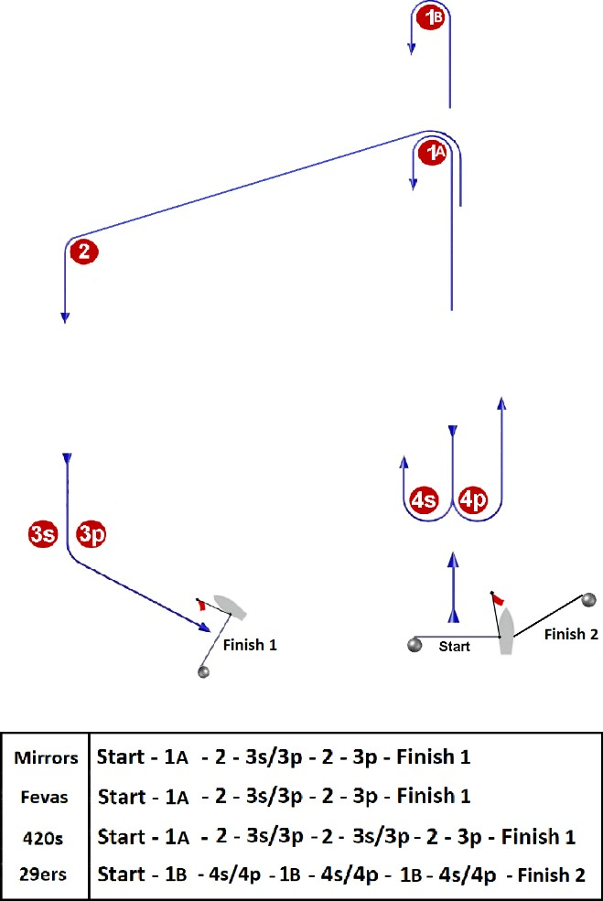

**ADDENDUM B contd.**

**Mirror course Friday only**

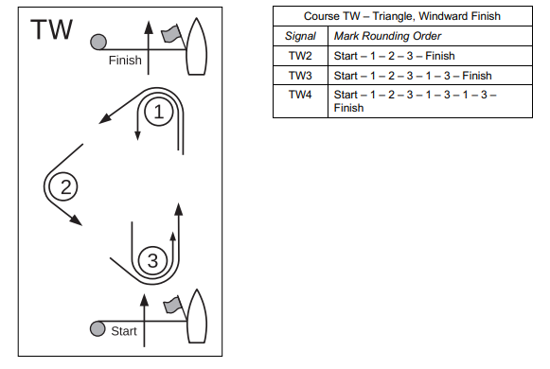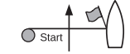

Finish

**Mark rounding order**

**Start – 1 – 2 – 3 – 1 – 3 - finish**