Double Ree 2026
Sailing Instructions (SIs)

AMENDMENT No 2

SI 7.1 Class Flags is changed so that Class Flags will be as follows:

Mirrors
Numeral Pendant 6 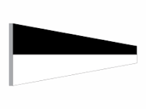
_____________________________________________________________
420s
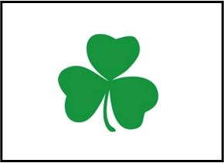

SOD Class Flag (Green Shamrock on a white background)

Other Classes remain unamended as per SI 7.1

David Dickson PRO 24th July 2026 18:00

